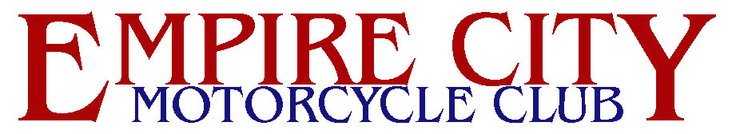
HISTORY AND MISSION STATEMENT

Empire City Motorcycle Club, Inc. of New York City, was founded by a group of twelve motorcycle riders in October, 1964 as a motorcycle owner/rider club. It is the oldest ongoing gay organization east of the Rockies and continues to be a vital part of the gay community in the New York Metropolitan area.

Club events actively promote both the sport of motorcycling and brotherhood in our community. Group rides, scheduled throughout the riding season, provide the opportunity to explore regional riding venues and to enjoy the camaraderie of the group experience. Social events are held to both bring the members of the organization closer together and to help others to get to know the membership.

As part of the ongoing commitment to safety, Empire City Motorcycle Club has sponsored and participated in Motorcycle Safety Foundation rider training programs. Our group rides, led by our Road Captain, always emphasize safe group riding techniques.

There are two major events in the Empire City Motorcycle Club's annual social calendar. The Bikers' Picnic, held annually since 1969 around Memorial Day, is open to all motorcycle operators and their buddy riders free of charge to the participants as Empire City's gift to its friends and supporters. In recent years, the evening before the Bikers' Picnic has been designated as the Bike Christening/Blessing where we call on a Higher Power to watch over riders and machines. Our Christmas Party, an annual event since 1964, is an event designed to celebrate the joy of the holiday season and to share that joy in the form of a "Toys for Tots" drive for local charities. In addition to the annual events, Empire City has presented the First Empire, its first run, and celebrations of the fifteenth, twentieth and twenty fifth anniversaries that included motorcycle tours of the Eastern seaboard and of New York State.

Current membership includes charter members who have been involved since the formation of the organization. Former Empire City members went on to found Cycle M.C., Commanders M.C., Wheels M.C. and Nova M.C.

Membership requirements are ownership of a legally registered and insured motorcycle and possession of a valid drivers' license with appropriate motorcycle endorsement. Men interested in membership must be sponsored by two members in good standing.
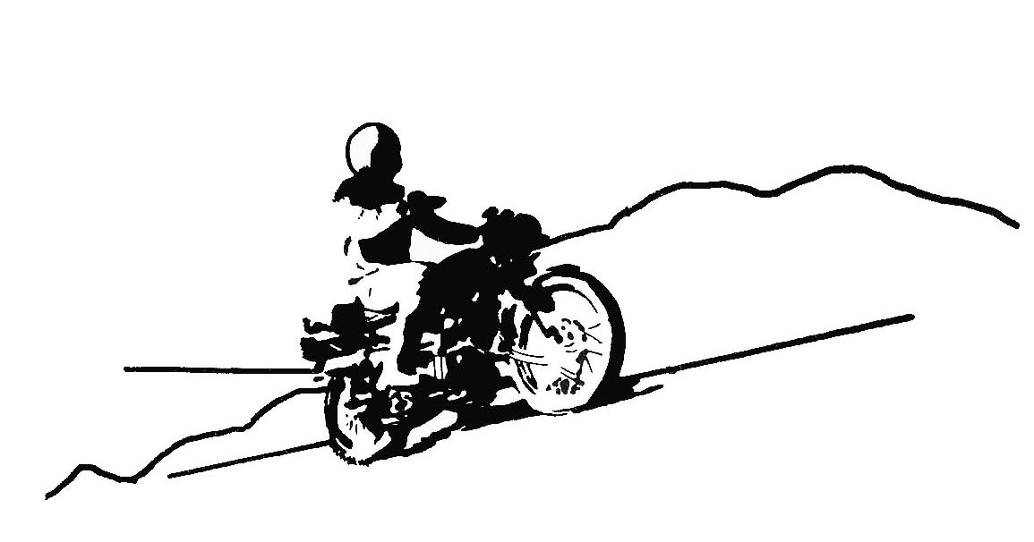

FROM AN EVENT AD - PICNIC RUN - JUNE 1, 1974

